* For updating resources, two options are available.
  + The first one is PUT, which should be used for full updates, i.e. all fields of the resource should be overwritten or set to their default values.
  + A PUT request to api/authors/authorID would update the author with that ID.
  + To request payload, insert a presentation of the resource we want to update, including all fields.
  + If a field is missing, it should be put to its default value,
  + and the response payload can be that updated author or can be empty.

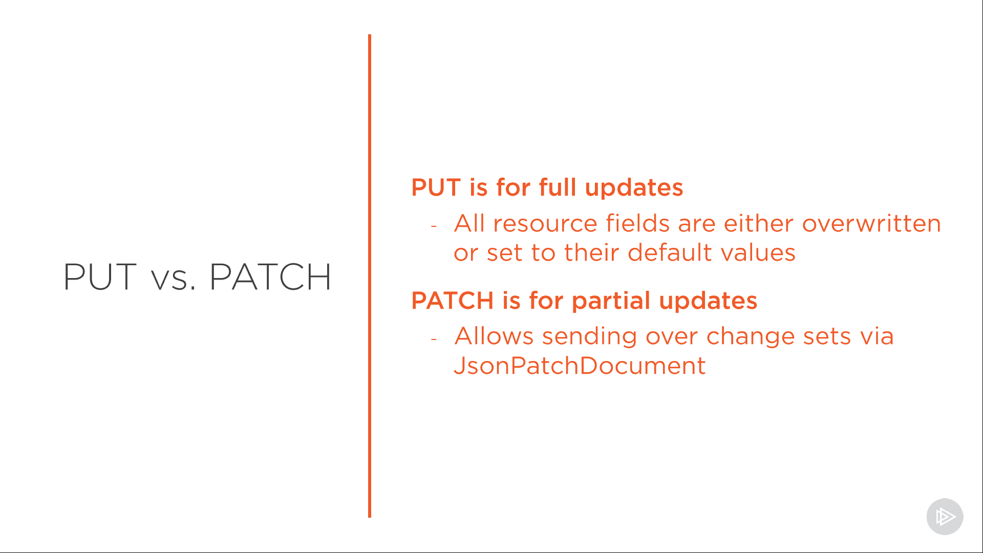

* + But you don't always want to fully update a resource. In fact, more often than not, you'll need partial updates to update only one or two fields instead of all of them, and that's what the PATCH method is for.
  + The URI is the same as for PUT,
  + but the request payload is somewhat special. It's a JsonPatchDocument, essentially instead of changes that should be executed on that resource.
  + We'll look into it in more detail once we start talking about partial updates later on in this module.
  + As far as the response payload is concerned, just as with PUT, it can be that updated author or it can be empty.
* the fact that PUT is used less and less these days. Imagine a resource with 30 fields. It's not that good for performance that the consumer of the API must send over all these field values when he just wants to change one. That's why PATCH for partial updates is often the preferred option.